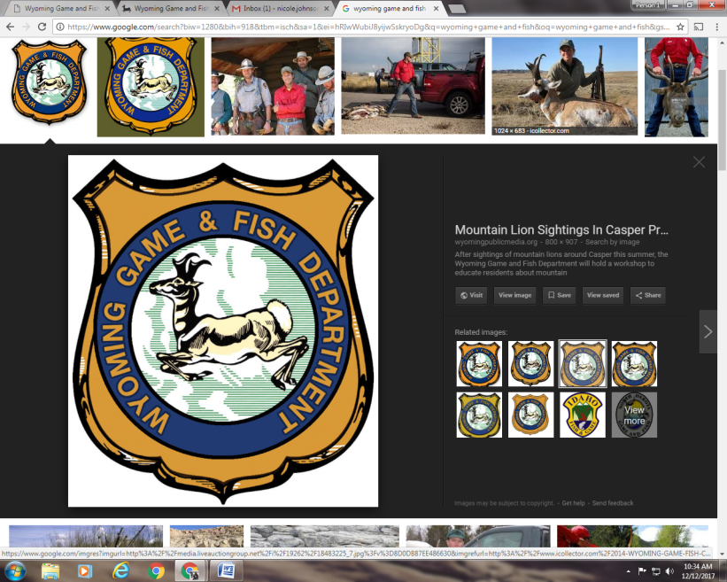**FREE** HUNTER’S

EDUCATION COURSE

YOUTH 17 & UNDER

WHERE:

WHEN: JANUARY 16th, 17th & 23rd,24th(TUESDAY & WEDNESDAY)

TIME: 6:00-9:00pm

MUST SIGN UP

SIGN UP SHEET: LOCATED AT – Osmond Elementary

3120 WY-241, Afton WY 83110

CLASS SPACE IS LIMITED. MUST BE SIGNED UP ON THE PHYSICAL SIGN UP SHEET TO ATTEND DAY 1 OF CLASS - ON DAY 1 OF CLASS STUDENTS IN ATTENDANCE OF DAY 1 OF CLASS WILL HAVE TO REGISTER FOR THE CLASS ONLINE AT [WWW.WGFD.WYO.GOV](http://WWW.WGFD.WYO.GOV) BEFORE DAY 3 OF CLASS.

MUST BE ONTIME OR EARLY TO ALL CLASSES- STUDENTS MUST BE PRESENT AT EVERY CLASS TO GET CERTIFIED

RECCOMMENDED READING: CHAPTER’S 1-10 OF THE WYOMING HUNTER EDUCATION STUDENT MANUAL

QUESTIONS: CALL NIKI AT THE JACKSON REGIONAL OFFICE 307-733-2321