**Osmond Elementary School**

*Smart Start Plan Summary*

*Updates to Osmond Elementary School’s Smart Start Plan will be communicated to all stakeholders as additional information becomes available in coordination with the Lincoln County Public Health Office.*

**Masks**

* Students, teachers and school staff shall wear face coverings both indoors and outdoors where 6 feet of separation cannot be maintained. (Statewide Order effective August 1)
* Some exemptions are allowed- medical condition, mental health condition or disability that prevents wearing a face covering. Documentation will be required.
* Alternate face coverings may be considered during the school day for instructional purposes.

**Transportation**

* Six foot spacing of students during transportation to and from the facility shall be maintained as much as practicable; face coverings shall be worn during transportation when six feet of separation cannot be maintained (Statewide Order effective August 1).
* Buses will be sanitized before each run.

**Recess**

* Students will be allowed to be outdoors for recess. Extra sanitization precautions of play equipment will be taken. Students, teachers and school staff shall wear face coverings both indoors and outdoors where 6 feet of separation cannot be maintained (Statewide Order effective August 1).
* Students will use school equipment only. Students are prohibited from bringing equipment from home (basketballs, footballs, etc.).

**Positive Test for COVID19 in Classroom (student or staff)**

* LCSD#2 will work in collaboration with the Lincoln County Public Health Office. Considerations, on a case-by-case basis, will be made for the following: communication, sanitization, temporary re-location of classroom and targeted closing based on public health orders.

**Music**

* Band and orchestra classes will be suspended until September 14 at which time a decision will be made based on current available data regarding next steps for music.
* General music will be offered to all 4-6 grade classes.

**Lunch**

* Students may be eating in the cafeteria or in their classroom.
* School meals will be pre-packaged.
* Microwaves will not be available for students.

**Cleaning/Sanitization**

* Additional measures for cleaning and sanitization will be taken, ie: additional custodial staff hired and disinfection of surfaces throughout the day. All cleaning products meet the requirements of the CDC and OSHA.

**Remote Learning vs. Virtual Learning**

* **Remote** **Learning** - Instruction delivered by a teacher located in a physical classroom with students present while also providing simultaneous remote instruction. Remote education instruction is delivered through interactive, synchronous technology which allows the student receiving the remote education to ask questions, make comments, and interact in real-time with the teacher, classroom students, and other remote students. Students must be enrolled in LCSD#2. Attendance will be taken morning and afternoon. **Remote learning will be made available on a temporary basis only**.
* **Virtual Learning** - Instruction is primarily delivered through technology and can be asynchronous or synchronous. **This service is not available at this time for students in grades K-6**. We are working on getting approval to offer this for students in grades 7-8. Students in grades 9-12 have this option available. Students must be enrolled in LCSD#2.

**Students on an IEP**

* Considerations by the IEP Team (including the parent) for students with IEP's that have communication needs, medical needs, and other at-risk factors to access the general curriculum in Tier 1.
* Options for remote IEP meetings will still be available and encouraged.

**Parent Responsibilities**

* Home Screening

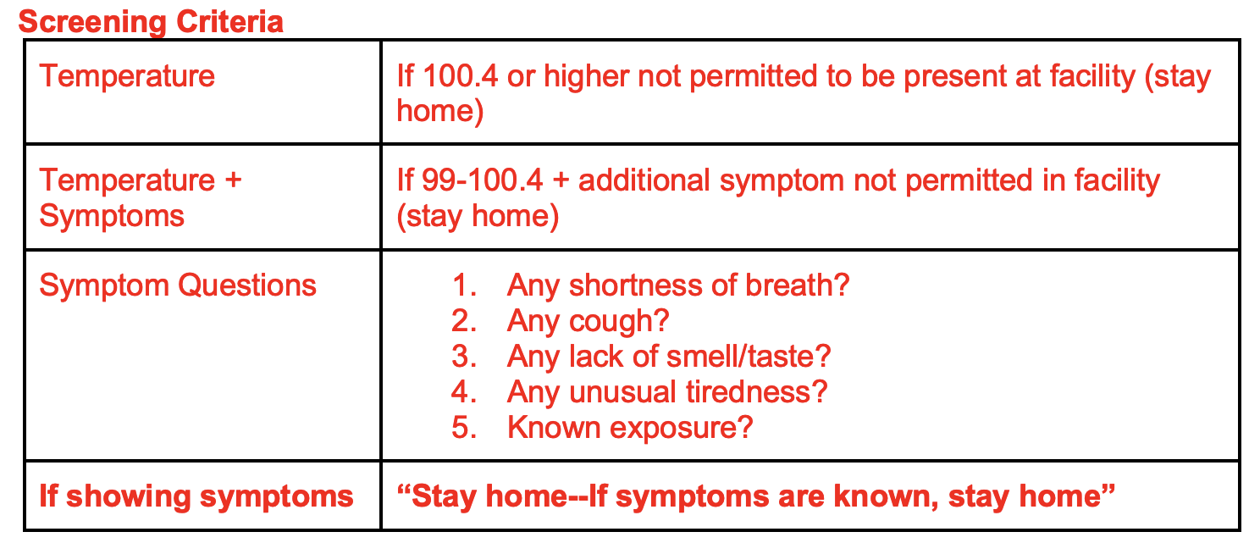**Please screen your child daily for symptoms of COVID-19 before sending them to school.**

* Send your child to school with a clean mask every day.
* Send your child with a water bottle. Drinking fountains will be shut off but filling stations will be available.
* Please do not send/bring classroom treats.
* Volunteers and parents/guardians are welcome to come into the office but are prohibited from entering other parts of the building at this time.

**For future updates, please check the district website at lcsd2.org**